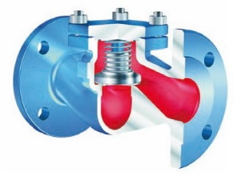
Check Valves
Type 05110
Check Valves, PN16
Body and cap in cast iron
seat and disc in stainless steel, metal to metal seated

