Check Valves
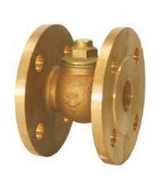
Type 05083
Check Valves, PN16
Bronze body, screwed cap in brass
Flanged connection acc. to DIN EN 1092-1 PN16
Disc with FPM seal
Available options - on request only:
· Disc with PTFE seal

