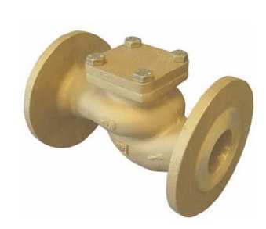
Check Valves
Type 05082
Check Valves, PN16
Bronze body and cap
metal to metal seated

