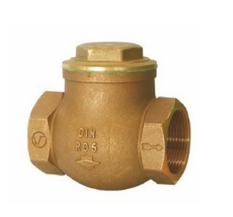
Check Valves
Type 05040
Check Valves, swing type, PN16
Bronze body, screwed cap in brass
Female thread connection (G) acc. to ISO 7-1 Rp

