Check Valves
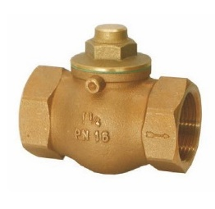
Type 05011, Type 05012
Check Valves, PN16, DIN EN 3845-2
Bronze body, screwed cap in brass
Part No. 05011.X.0000
Female thread connection (G) acc. to ISO 7-1 Rp
Disc with FPM seal

