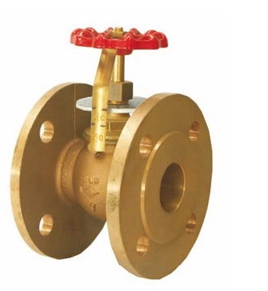
Control Valves
Type 04041
Control Valves, PN16
Control characteristic: linear
Bronze body, screwed topwork in brass
with opening indicator

