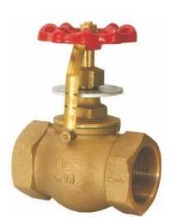
Control Valves
Type 04020
Control Valves, PN16, DIN 3844
Control characteristic: linear
Bronze body, screwed topwork in brass
with opening indicator

