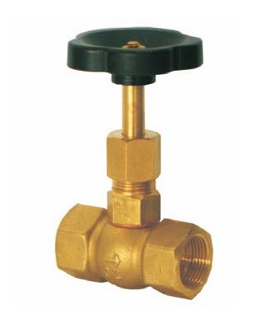
Needle Valves
Type 04010
Needle Valves, PN40
Brass body and topwork
with needle cone

