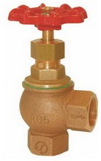
Angle Valves
Type 01131
Globe Valves, angle type, PN16
Bronze body, screwed topwork in brass

